Practical 8

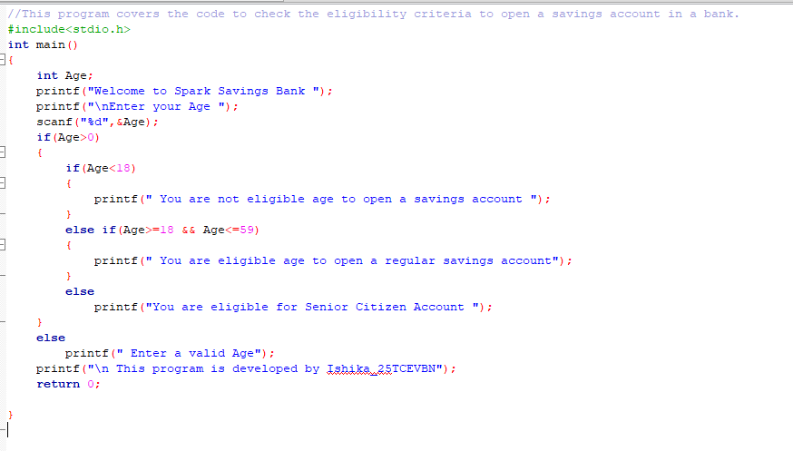

If age is less than 18

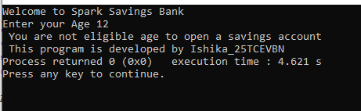

If age is greater than or equal to 18 and less than 60

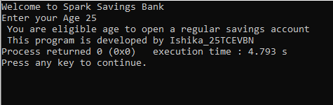

If age is greater than or equal to 60

